Practical-13
PHP JSON API and AJAX/Fetch-Based CRUD without Page Reload
Theory :
- Do PHP endpoints return valid JSON responses?
Answer: Yes, PHP endpoints return valid JSON responses for frontend communication.
- Are GET and POST requests handled properly?
Answer: Yes, GET and POST requests are handled correctly to retrieve and submit data.
3. Are loading, success, and error states shown on the frontend? Answer: Yes, appropriate loading indicators and success or error messages are displayed.
4. Is input validation performed before database operations?
Answer: Yes, user inputs are validated before performing database operations.

Result:

- Student panel management via api

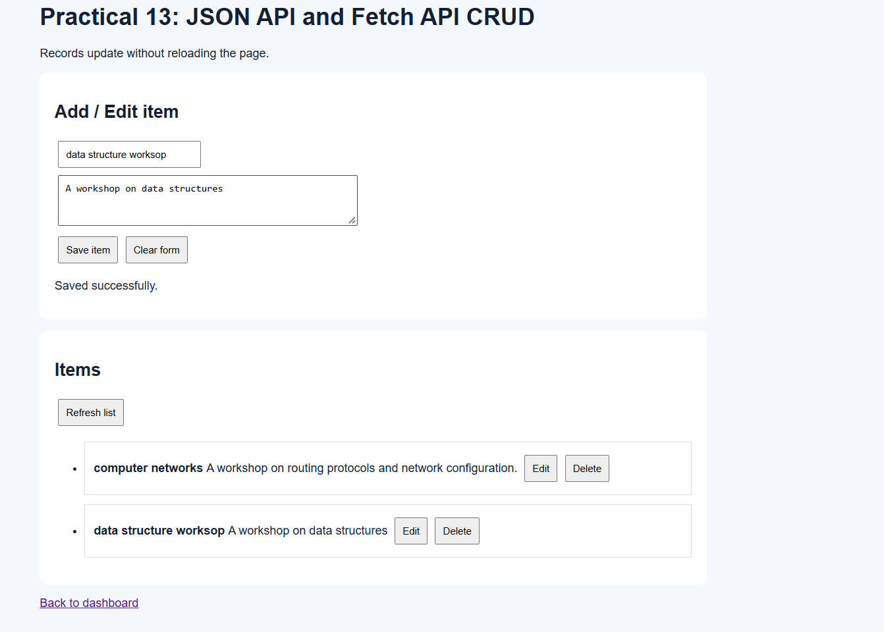
2)student panel managed by admin via api health
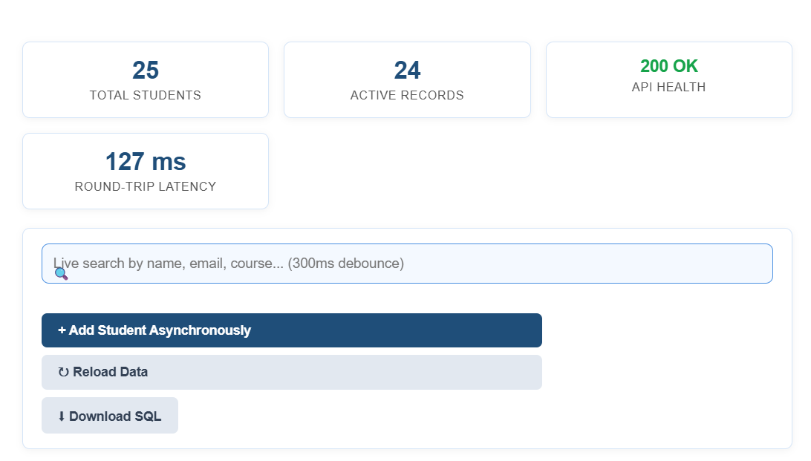
3)sample data management via api

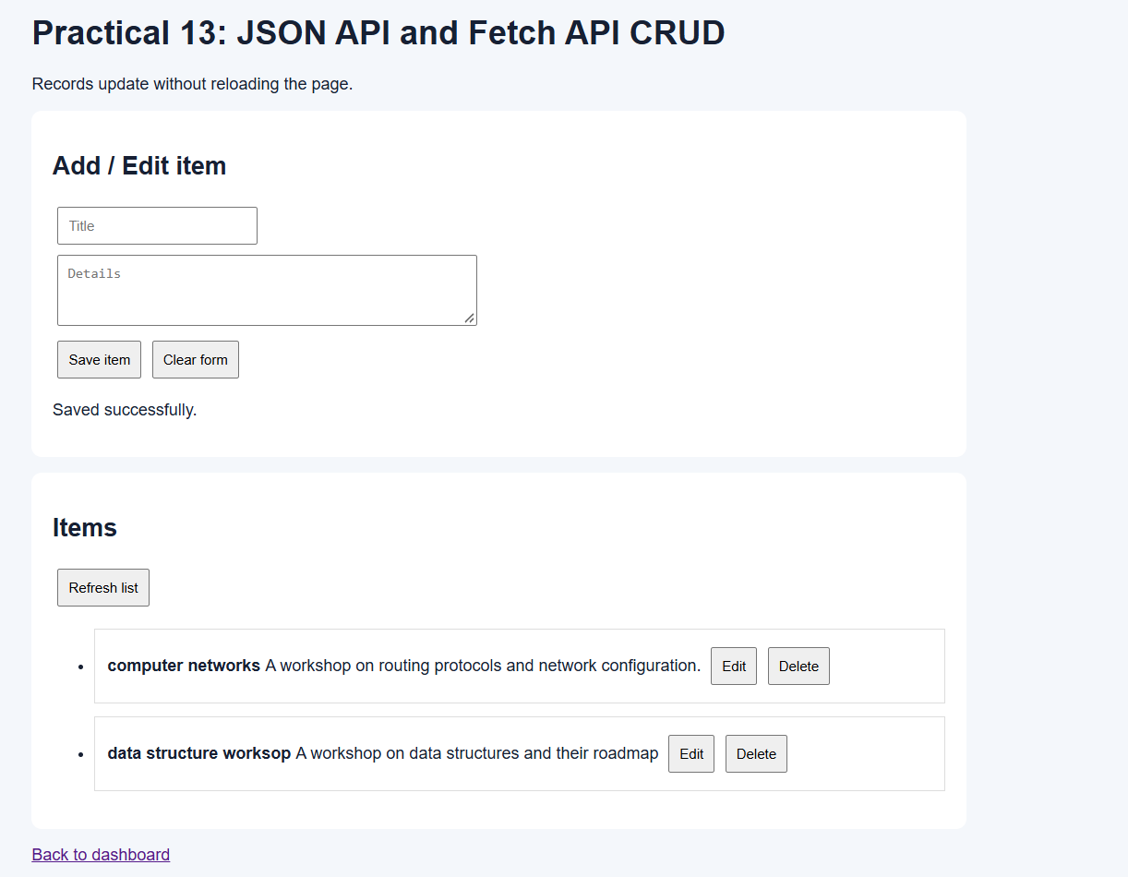

Git Hub Repository Link:
https://github.com/25dce046/STUDENT-HUB-PORTAL

Challenges Faced: I faced difficulties in creating PHP endpoints that return valid JSON responses. I struggled with using the Fetch API to perform CRUD operations without reloading the page. I also faced challenges in handling errors, validating inputs, and displaying appropriate messages.
Learning Outcome: I learned to create PHP JSON APIs and connect them with JavaScript using the Fetch API. I understood how to perform CRUD operations asynchronously without reloading the page. I also learned to validate user inputs and handle loading, success, and error messages.

